**Unit 2 – Worksheet 4**

**Multiple Representations of Motion**

Adapted from ⓒAMTA 2016

1. A motion map for a running bug is given below. The dots on the motion map below occur in 1.0 second intervals.

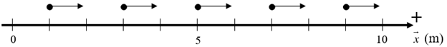

* 1. Describe the motion of the bug as completely as you can.
  2. Modify the *Pyret* program below that can generate the positions of a moving object. Look over the entire code with the goal of understanding how this could represent the bug’s motion.

# next-x :: Number -> Number

# write an explanation below of what the function consumes and produces

# consumes a ....

#

#

# Set the values for the velocity (assume meters/second), and for the time interval

v = ____________ # object’s velocity

delta-t = ___________ # time interval between motion map’s dots.

# check the function next-x

**examples:**

next-x(5) **is** _______________# sample function check

next-x(3) **is** _______________# complete this

next-x(__) **is** _____________ # complete this

**end**

**fun** next-x(x)**:**

# Complete the body of the function below

**end**



*Motion map of a running bug.*

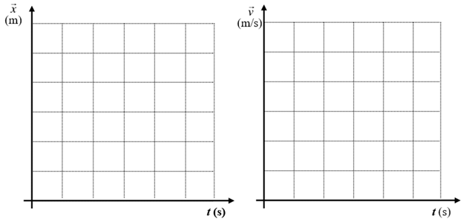

* 1. Using the motion map, create and label both position vs time and velocity vs time graphs.
  2. Write the mathematical representation that gives the relationship between the bug’s position and the time.
  3. Write the mathematical representation that gives the relationship between the bug’s velocity and time.
  4. In the velocityvs. time graph, shade the area between the graph’s line and the time axis. Determine the area of the shaded region. In what units is this area measured?
  5. From the motion map, determine the bug’s displacement from 0 to 4 seconds. Compare this displacement with the area from the velocity vs time graph.

1. Answer the following questions based on the position vs time data below.

|  |  |  |  |  |  |  |  |  |  |  |
| --- | --- | --- | --- | --- | --- | --- | --- | --- | --- | --- |
| $t$**(s)** | 0 | 1 | 2 | 3 | 4 | 5 | 6 | 7 | 8 | 9 |
| $\overset{⃑}{x}$**(m)** | 0 | 2 | 4 | 4 | 7 | 10 | 10 | 10 | 5 | 0 |

* 1. Draw quantitative graphical representations of $\overset{⃑}{x}$ vs $t$ and $\overset{⃑}{v}$ vs t on the axes below.



* 1. Draw a quantitative motion map for the object.



* 1. Determine the displacement from *t* = 3.0 s to 5.0 s using the velocity vs. time graph. Shade the graph and show your work.
  2. Determine the displacement from *t* = 7.0 s to *t* = 9.0 s using the velocity vs. time graph. Shade the graph and show your work.